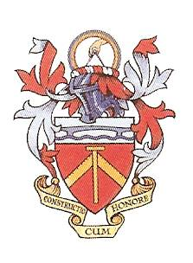

Common Hall Agenda 19th September 2024

1. Welcome – the Master

2. Announcement of those nominated by the Court for election – the Clerk.

3. Report – the Master. The Master’s Year 2023/24: activities and issues.

4. Report – Membership Attraction Committee

5. Report – Membership Services Committee (Committee Yet to Form Brief by MW)

6. Report –: Education and Awards Committee:

7. Report – : Merchandise IT Committee:

8. Report – Climate Action Committee –

9 Report – Diversity & Inclusivity Committee

10. Report – Overview of Finance:

11. Overview – Charitable Trust: HCA & Chair HCA Paul Shepherd CBE

12. The View going forward by The Master Elect Dr Deborah Pullen MBE

13. Questions from the floor and discussion – chaired by the Master.

14. Conclusion – the Master

