Unlocking Potential event 21 May 2026

The Worshipful Company Of Constructors were delighted to host The Glasshouse CIC at our Unlocking Potential event on 21st May at which they ran a plant workshop. After an introduction from the Master, Tim Fitch and Chair of our EDI Committee, Diana Chrouch OBE, we heard about the great work the Glasshouse do in training and supporting female prisoners in horticulture skills and then recruit them upon their release. We heard from one of their staff who shared some of her experiences including how she missed being able to see the sky when in prison.
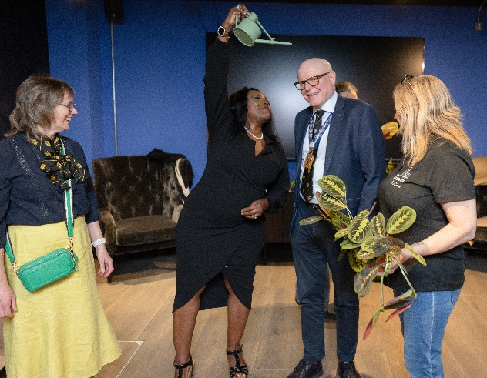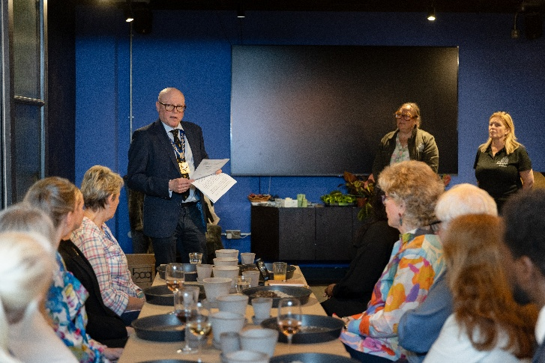
We then went on to learn about planting and caring for houseplants from the Glasshouse staff and were lucky enough to plant up 2 plants each that were then wrapped up by their staff for us to take home. In the relaxed setting, we were able to ask questions about caring for plants.
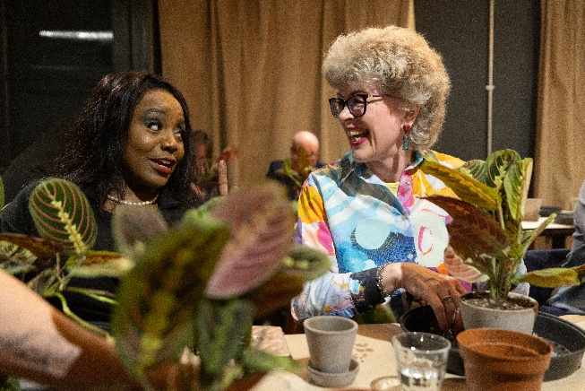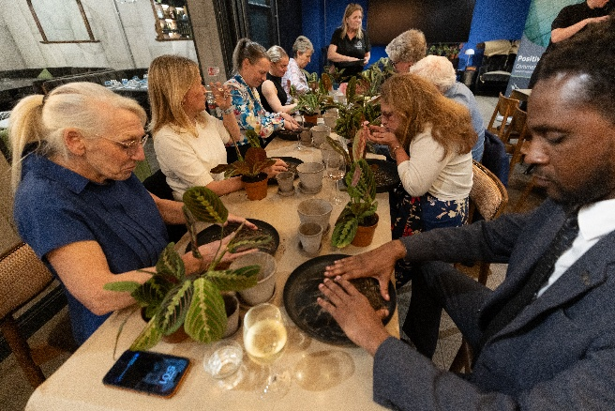
The evening finished with some networking over some great food and drinks supplied by the Chamberlain Hotel, The Minories . Thank you to all those who attended, our sponsors TUDOR ROSE ASSOCIATES LIMITED & John Rowsell Associates and to Kali Hamerton-Stove and her staff for a great evening enjoyed by all.

The Glasshouse is a community interest company that install & maintain plants in offices & recruit female ex-offenders. They have a 0% re offending rate compared to an average of 58% of women being reconvicted within a year of release. 52% of their workforce is made up of women with lived prison experience. All the women completing their programme are released into safe, stable accommodation. (stats from The Glasshouse Impact report 2025).
You can help the Glasshouse in the following ways:
- Have the Glasshouse install and maintain the plants in your office.
- Run your own plant workshop within your company
- Order plants through their website as gifts or to treat yourself.
https://www.theglasshouse.co.uk/our-services

